Java Homework 1

1.Write an application program that inputs three integers from the user by using input dialog and displays the sum, average, product, smallest and largest of the numbers on the message dialog.

Case I: without defining any function in your program except the main function.
Case II: define “smallest” and “largest” function in your program.

- Please describe how the Java application program is executed by usig this problem.
- Please describe the differences between these two cases in your programs.

- Write an Java applet program that displays a BMI of a person given his or her weight (in pounds or in kilograms ) and height (in inches or in meters ).

The formulas for calculating BMI (Body mass Index) are
BMI = 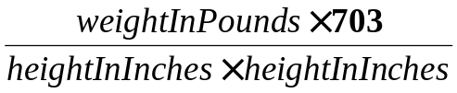
or
BMI = 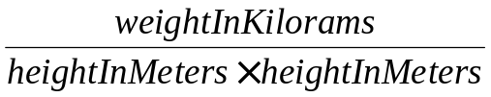
Also display the person is “Underweight”, “Normal”, “Overweight”,
“Obese” according to the following information:

BMI VALUES
Underweight: less than 18.5
Normal: between 18.5 and 24.9
Overweight between 25 and 29.9
Obese 30 or greater

Please describe how the Java applet program is executed by usig this problem.

3. Newton’s method:
y
f(x)

f(a)

x
a
b

在一般應用如最佳化或者數值分析上尋找根是一個相當重要的課題.
數值求根法以newton’s method 最為人使用. Newton’s method的優點除了方法簡單外, 收斂速度也相當快. 但其缺點為需要提供initial value for the search of the root. If the initial value deviates far away from the exact solution, then the search for the root cannot converge.

We can use geometric way to explain the newton’s method:

Assume that we want to find the root of the function f(x)=0.
At first, we guess the possible root on the x-axis is a.
Because it is just a guess, f(a) is not zero.
Then, we extend the line tangent at the point (a, f(a)) of the function f(x) to find out the intersection with x-axis of point b.
From these the three points: (b, 0), (a, 0), (a, f(a)) to form one triangle.
(I).From these triangle we can get tan=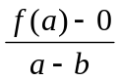
(II). Also tanis equal to the tangent slope (切線斜率) at point a, just as the differential value at point a of the function f(x).
So we have: tan= 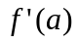
=
b = a － 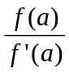
Here we have the equation using current point a to find the point b for the next search point.

(III). If the distance between the points of a and b are more approaching, the iteration will converge, we can find the root of f(x), otherwise it will diverge.

Problem:
Use Newton’s method to find out the square root of this positive integer n.
That is find x=.
Hint:

First we define on function: f(x) = 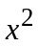- n
Second we find the derivative of f(x) = 2x
So we have the following:
b = a－ = a－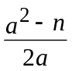 = 0.5 (a + 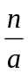)

- Please outline and list the drawing methods defined in the class Graphics.
(請整理及列出在class Graphics中和畫圖相關的函數)

